
K J Somaiya Institute of Technology
An Autonomous Institute Permanently Affiliated to the University of Mumbai DEPARTMENT OF INFORMATION TECHNOLOGY
Name of Student : Aditya Bali
Roll No : B - 71
Batch : SB4
EXPERIMENT 7
Aim:
Implementation of any one Graph Traversal Technique for real-world application.
Objective :
● To implement the Depth-First Search (DFS) graph traversal technique using C programming.
● To accept temperature readings from the user for different weather stations. ● To represent the connections between weather stations using an adjacency matrix.
● To traverse the connected weather stations using DFS and display their temperature readings.
Software Used:
● Turbo C / Turbo C++
● DOSBox
Theory :
Depth-First Search (DFS) is a graph traversal technique that explores a graph by visiting one vertex and then recursively visiting its unvisited adjacent vertices as deeply as possible before backtracking.
In this application, each vertex represents a weather station, and the edges represent connections between the stations. The user enters the temperature readings of each station and the adjacency matrix representing the connections. DFS starts from the selected station, visits connected stations, and displays their temperature readings.
The program uses a visited array to prevent revisiting stations and recursion to perform the traversal. DFS is useful for exploring connected weather monitoring networks.
Program :
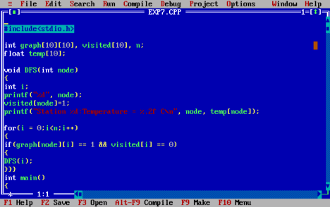
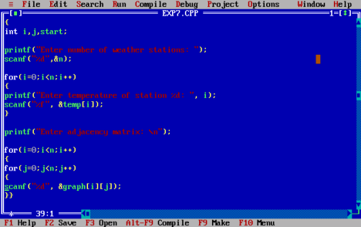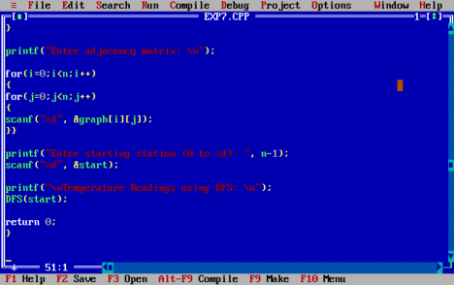
Output :
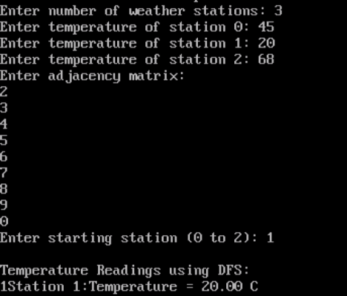
Algorithm :
1. Start.
2. Declare the graph adjacency matrix, temperature array, and visited array. 3. Accept the number of weather stations from the user.
4. Read the temperature readings of each weather station from the user.
5. Accept the adjacency matrix representing connections between the weather stations. 6. Accept the starting station for DFS traversal.
7. Mark the starting station as visited.
8. Display the station number and its temperature reading.
9. Check all adjacent stations. If an adjacent station is connected and unvisited, call the DFS function recursively for that station.
10. Continue the process until all reachable stations have been visited. 11. Stop.
Outcome :
The DFS graph traversal technique was successfully implemented in C to traverse connected weather stations and display their user-entered temperature readings.
Conclusion :
Thus, the Depth-First Search (DFS) technique was successfully implemented for a real-world temperature monitoring application. It helps explore connected weather stations and retrieve their recorded temperatures through graph traversal.

